PLYBOO BASSO® SERIES PANEL
DECORATIVE WALL PANELS
PRODUCT SPECIFICATION
IN CSI 3-PART FORMAT
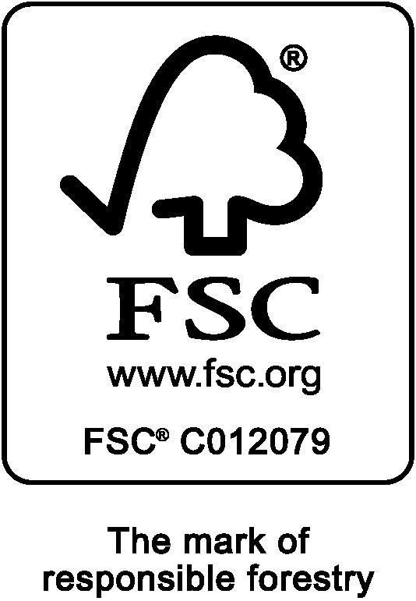
Smith & Fong Company
394 Bel Marin Keys Suite 6
Novato, CA 94949

Phone: (415) 896-0577
Toll Free: (866) 835-9859
Fax: (415) 896-0583

Website: www.plyboo.com
E-mail: SALES@PLYBOO.COM
The BASSO® Series.

SECTION 09 74 13
DECORATIVE WOOD WALL PANELS
PART 1–GENERAL

1.1 RELATED DOCUMENTS
General conditions and shop drawings of Contract, including General and Supplementary Conditions including Division-1 sections should they apply to the work of this section.

1.2 SUMMARY
- Section Includes:
  - Wall panels, unfinished or prefinished decorative bamboo wall panels.
- Related Sections:
  - Section 01350, Special Environmental Requirements
  - Division 26 (16) Sections – Electrical Work
- Substitutions
  - Submittals which do not provide adequate product information required in the specification will not be considered. The proposed substitution shall meet all requirements of this section to be considered.

1.3. REFERENCES
A. Test Methods:
- ASTM E 84 Standard Test Method for Surface Burning Characteristics of Building
Materials.
- California Special Environmental Requirements Specification Section 01350 Protocol: Standard Practice for Testing of Volatile Organic Emissions from Various Sources using Small-Scale Environmental Chamber CA/DHS/EHLB/R-174.

1.4 SUBMITTALS
- Product Data: Submit manufacturer’s data for each type of wall panel required,
- Samples: For each specified wall panel, submit 6-inch by 6-inch samples of panels.
- Certifications: Submit copies of independent third-party certifications which meet specified requirements and related certified independent laboratory reports showing compliance with specified tests and standards.
- Shop Drawings: Submit shop drawings indicating wall panel layout, required trim, and seam locations for this project.

1.5 QUALITY ASSURANCE
Manufacturer Qualifications: Minimum 10 years of experience in producing bamboo wall panel products.
Emissions Levels: Where indicated in Division 1 and, or Part 2, Products, quality assurance includes a copy of the laboratory letter verifying the product has been tested per California Special Environmental Requirements Protocol.
Applicable LEED™ Credits:

1. Low-Emitting Materials – Formaldehyde emissions evaluation
Product meets one of the following: EPA TSCA Tile VI or California Air Resources Board (CARB) ATCM for formaldehyde requirements for ultra-low-emitting formaldehyde (ULEF) resins of EPA TSCA Title VI or CARB ATCM formaldehyde requirements for no added formaldehyde resins (NAF).
2. Building product disclosure and optimization – sourcing of raw materials Bio-based materials.
Bio-based products must meet the Sustainable Agriculture Network’s Sustainable
Agriculture Standard. Bio-based raw materials must be tested using ASTM Test Method D6866 and be legally harvested, as defined by the exporting and receiving country. Exclude hide products, such as leather and other animal skin material. Products meeting bio-based materials criteria are valued at 100% of their cost for the purposes of credit achievement calculation. (FSC 100% certified)

1.6 DELIVERY, STORAGE AND HANDLING
- Wall panels are to be delivered to the project site in original, unopened packages and must be protected from moisture, direct sunlight, and damage.
- Storage temperatures should not be different from normal conditions of an occupied space, between 50 degrees F and 80 degrees F, with relative humidity between 35 - 55 percent.
- Before installing wall panels, allow to achieve room temperature of the conditioned environment.

1.7 WARRANTY
A. Submit a written warranty from the manufacturer available at: https://www.plyboo.com/wp-content/uploads/2021/03/20210311_SF_RLS-Warranty.pdf

1.8 MAINTENANCE
A. Extra Materials:
1.Wall Panels: Furnish extra quantity of units equal to 5.0 percent of amount installed.
PART 2 - PRODUCTS

2.1 MANUFACTURER
A. Wall Panels:
1. Manufacturer: Smith & Fong Company
- 394 Bel Marin Keys Suite 6, Novato, CA 94949
- Telephone: 415-896-0577
- Website: www.plyboo.com

2.2 WALL PANELS
A. Wall Panels: Type AWP-1:
- Material: 100% Bamboo (FSC 100% Certified)
- Surface Texture: (Prefinished)
- Surface Type: Patterned Curved and Textured
- Base/Core Composition: REALCORE®; Species: Moso bamboo (Phyllostachys Pubescens)
- Color: (Mist) (White Oak) (Beige) (Smoke) (Amber) (Bitterwood) (Noir)
- Patterns: (Basso B12)
- Standards/Certifications: (CARB II) (NAUF/FSC 100%)
- Thickness: ¾-inch (19mm)
- Width:47-3/4 inches (1213mm)
- Panel Heights:95-3/4 inches (2432mm)
- Edge Profile: Straight edge
- Flame Spread: ASTM E84; Class C (Class B available)
- Emission Testing: Section 01350 Protocol: No VOC’s with chronic REL’s (reference exposure level) detected, passes office, school and residential.
- Dimensional Stability: Standard – space must be enclosed with HVAC systems operating and with appropriate humidity levels maintained between 35%RH-55%RH at all times.
- Acceptable Product: Plyboo Basso® Series, as manufactured by Smith & Fong Company.
PART 3 - EXECUTION

3.1 EXAMINATION
A. All wet work such as concrete, terrazzo, plastering and painting
must be completed and thoroughly dried out before installing the product specified, unless expressly permitted by manufacturer’s printed recommendations.

3.2 PREPARATION
A. Measure the wall area(s) and establish layout of wall panel units per shop drawings and to ensure border widths are balanced at opposite edges. Coordinate panel layout with mechanical and electrical fixtures.

3.3 INSTALLATION
A. Install wall panels by attaching the panels to an existing wall per the manufacturer’s instructions and in accordance with the authorities having jurisdiction.
B. Install panels using a standard Z-clip system.

3.4 ADJUSTING AND CLEANING
- Replace damaged and broken panels.
- Perform routine maintenance involving frequent vacuuming to mitigate dirt accumulation. When needed, clean with a damp (not wet) cloth.
END OF SECTION

